**PROJECT - 4 : MEAN STACK IMPLEMENTATION**

UBUNTU UPGRADED

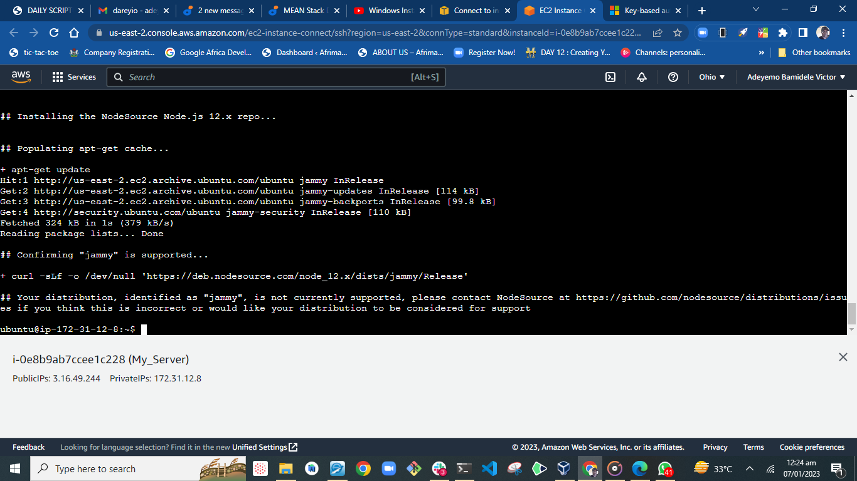

NODEJS INSTALLED

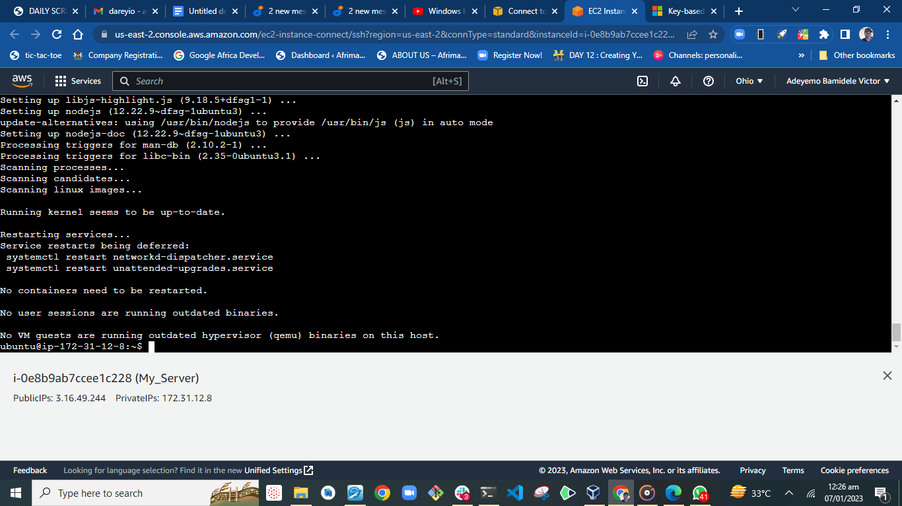

STEP-2 INSTALL MONGODB

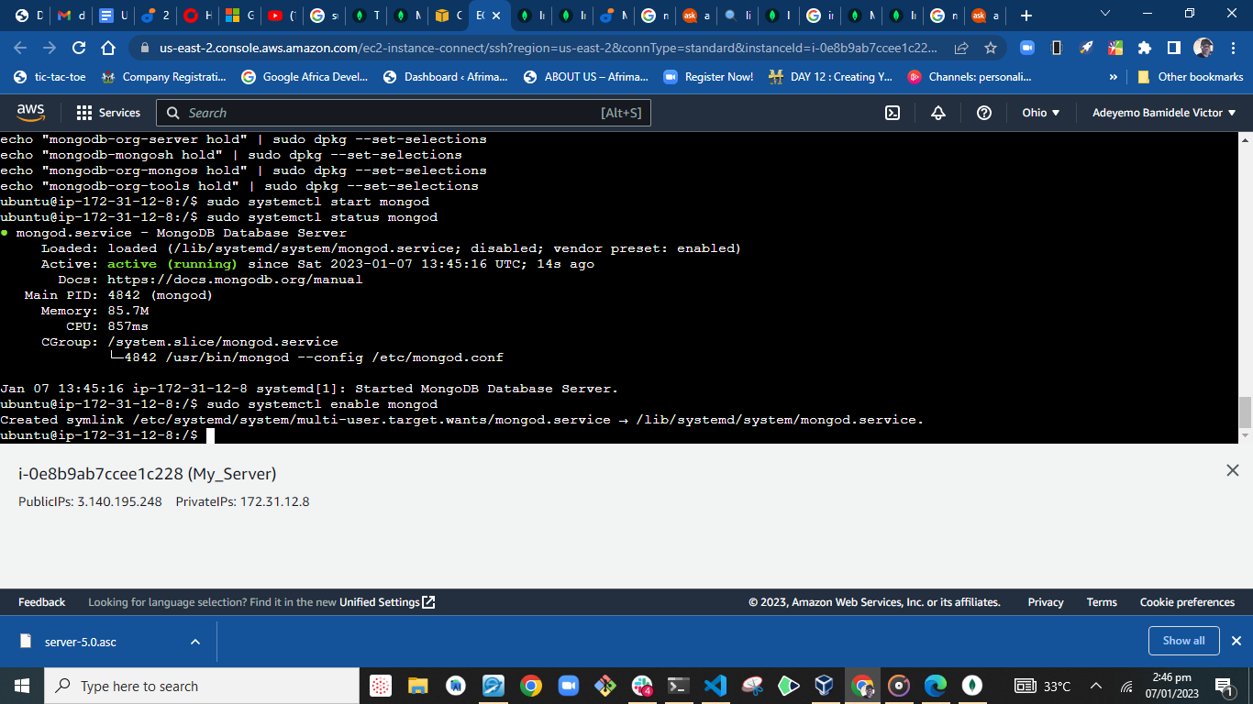

NPM INSTALLED

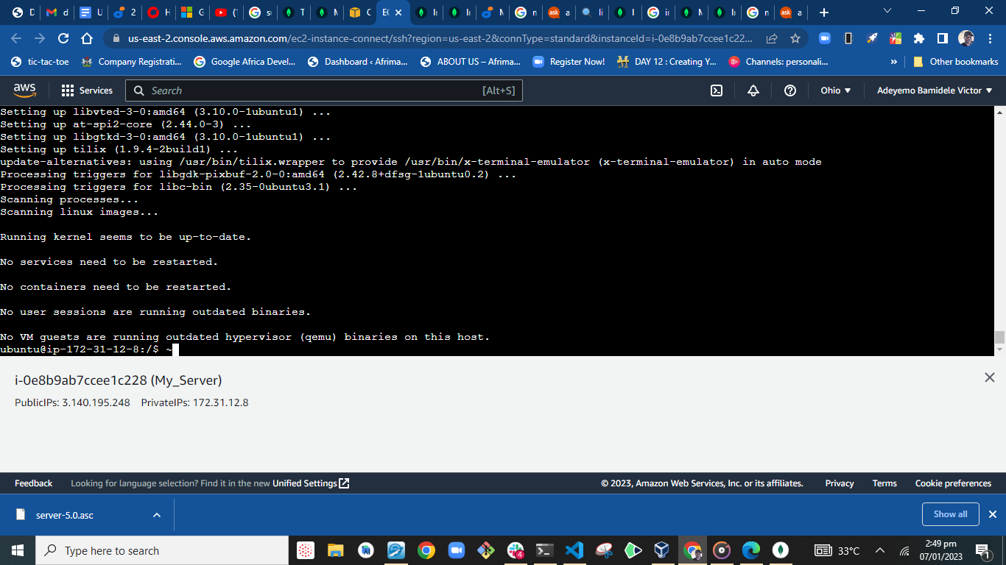

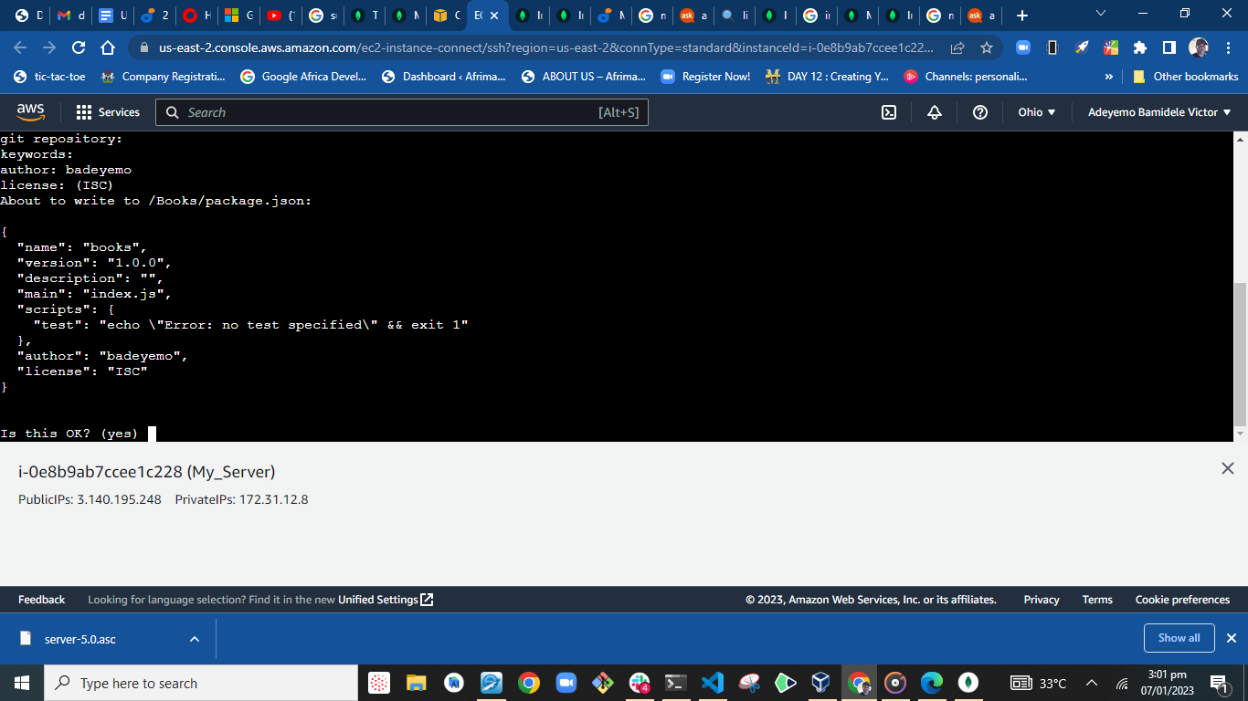

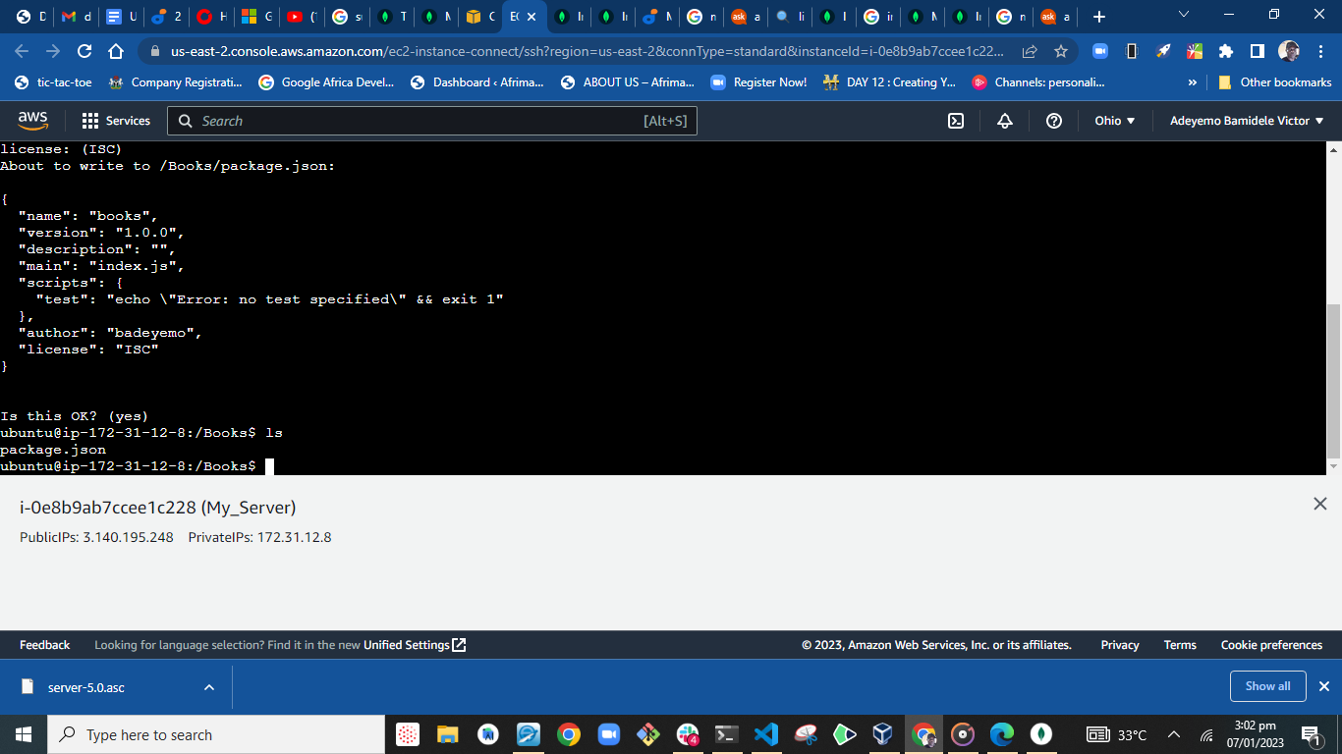

SERVER CONFIGURATION

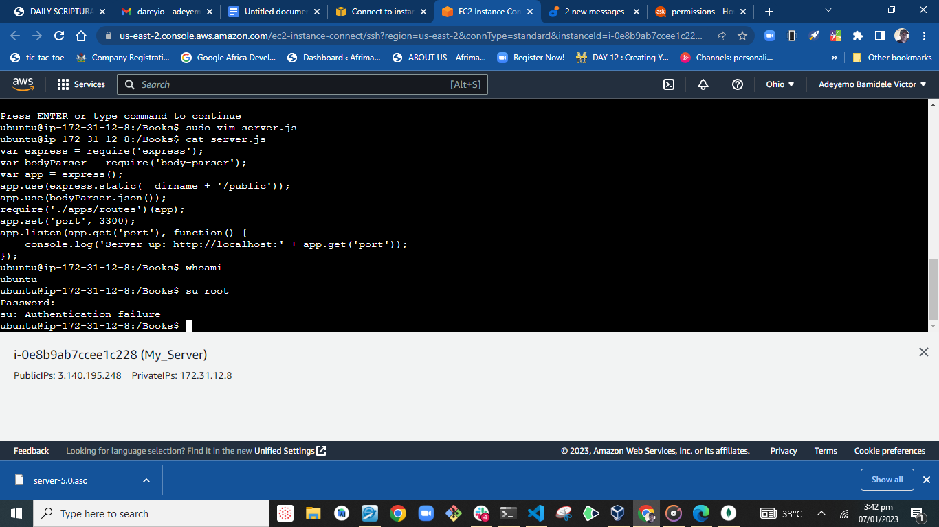

INSTALL EXPRESS AND SET-UP ROUTES TO THE SERVER

Install Express:

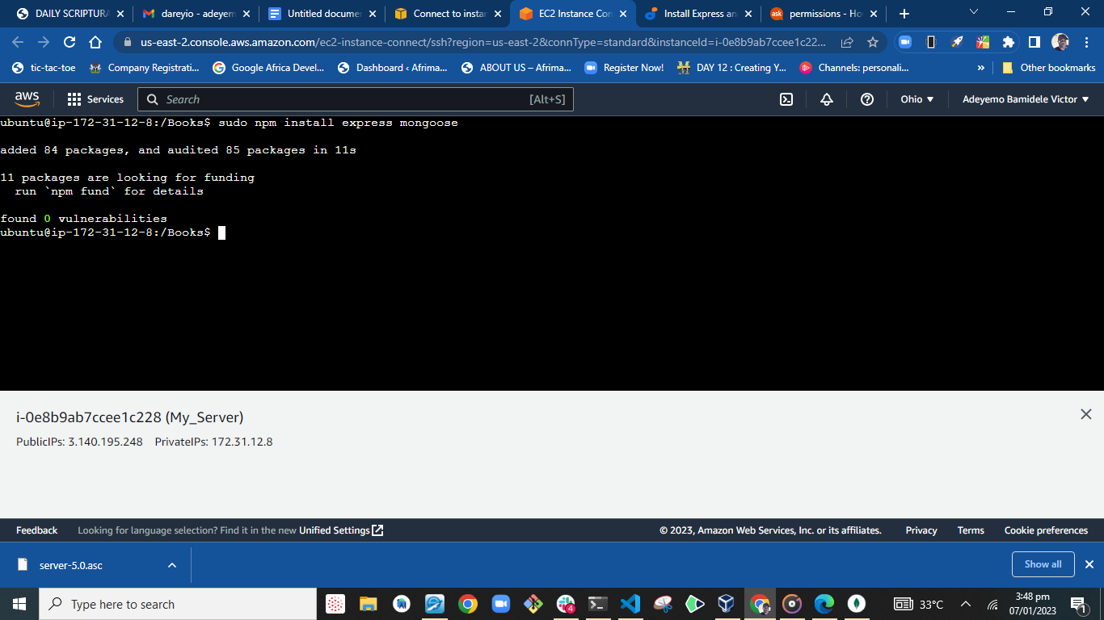

Populating Routes.js

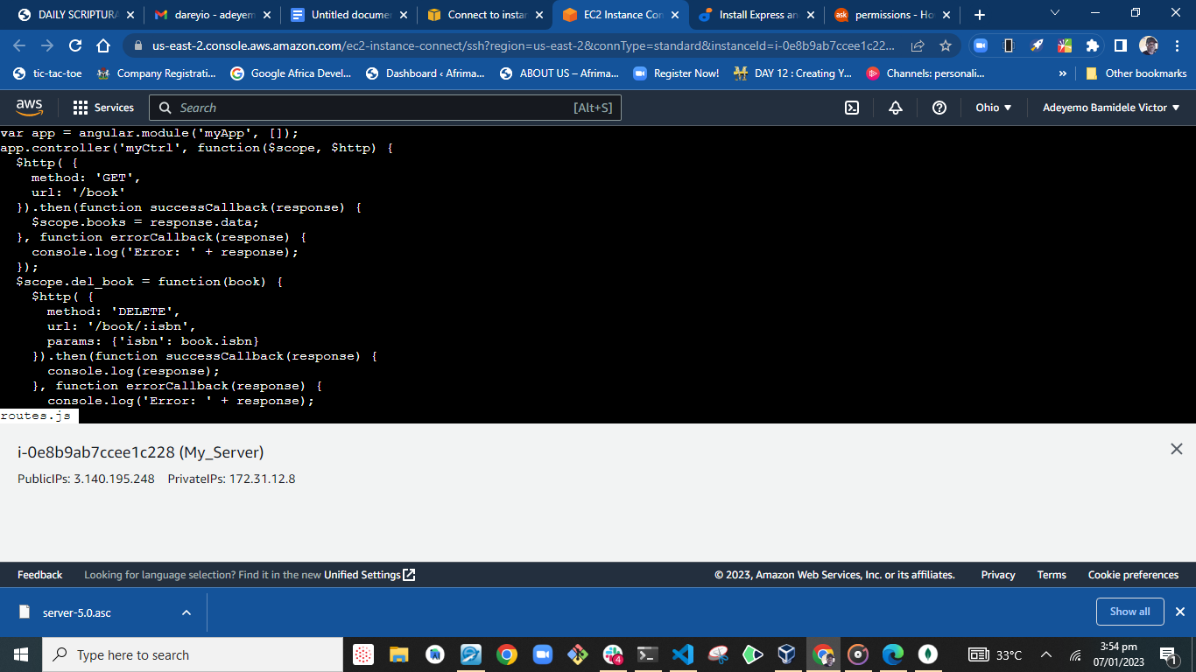

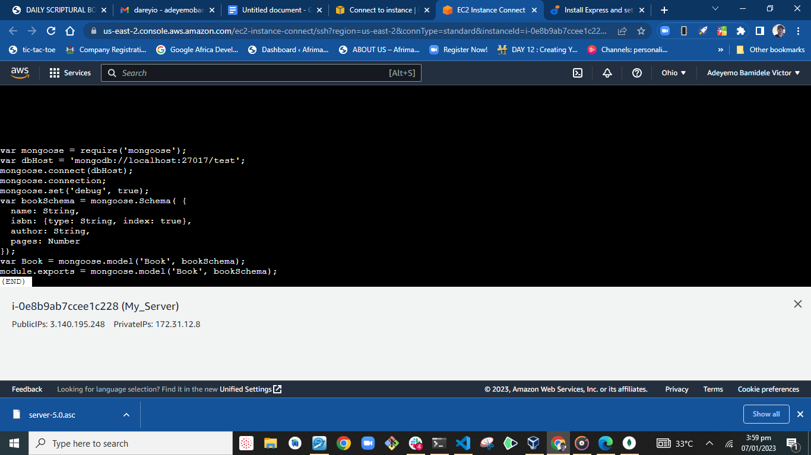

ACCESS THE ROUTES WITH ANGULARJS

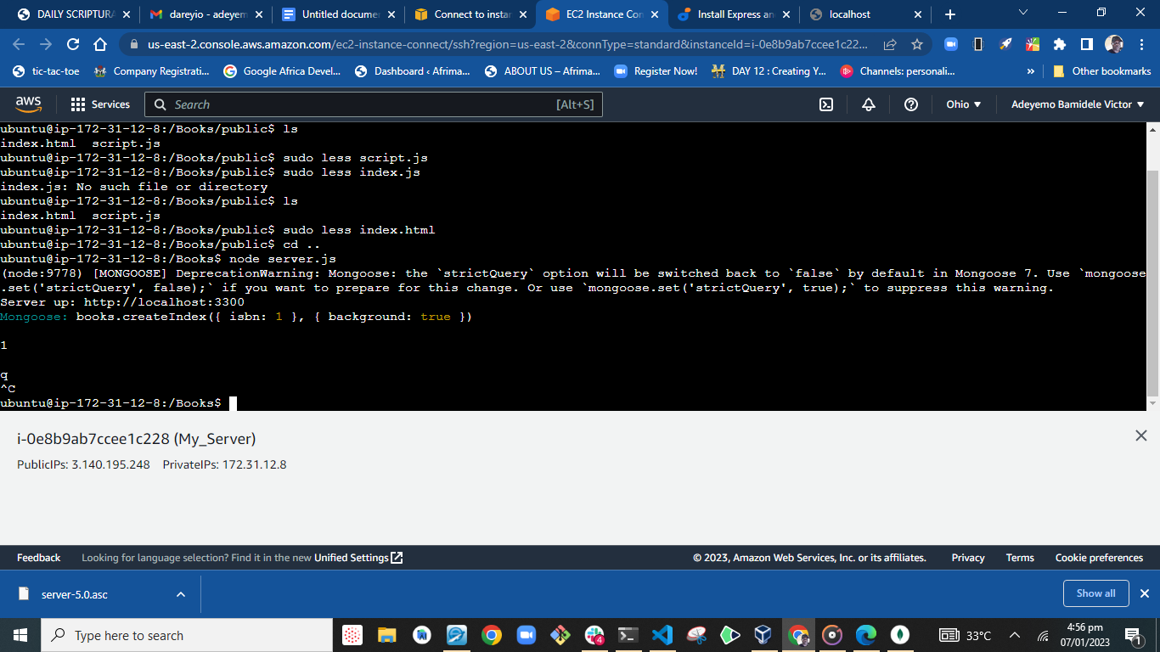

RUNNING NODE SERVER.JS

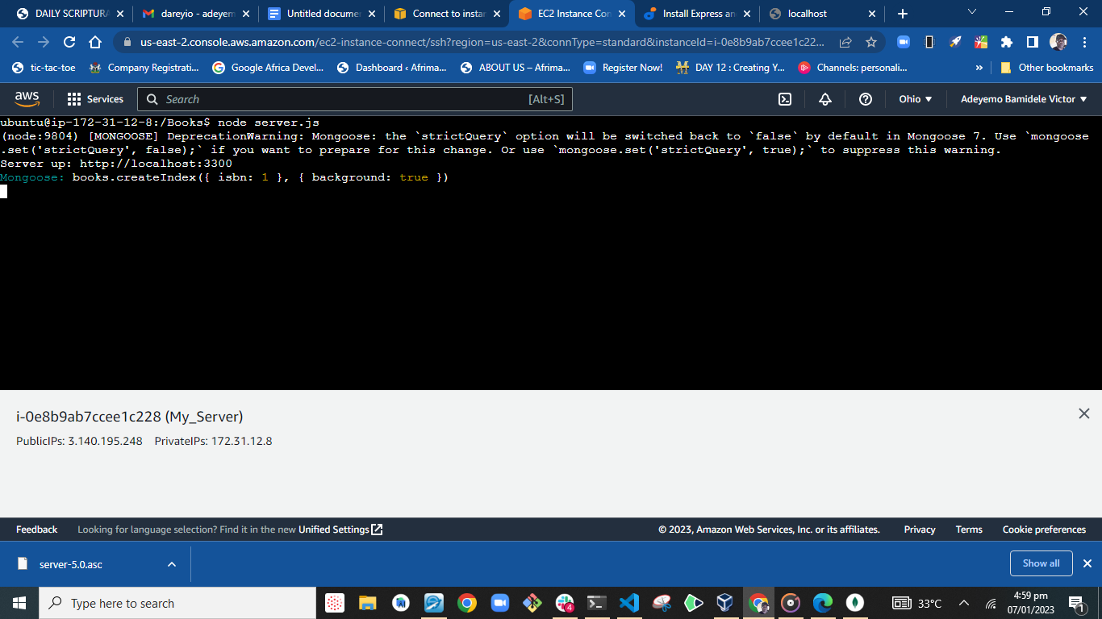

INVOKING: Curl -s <http://localhost:3300>

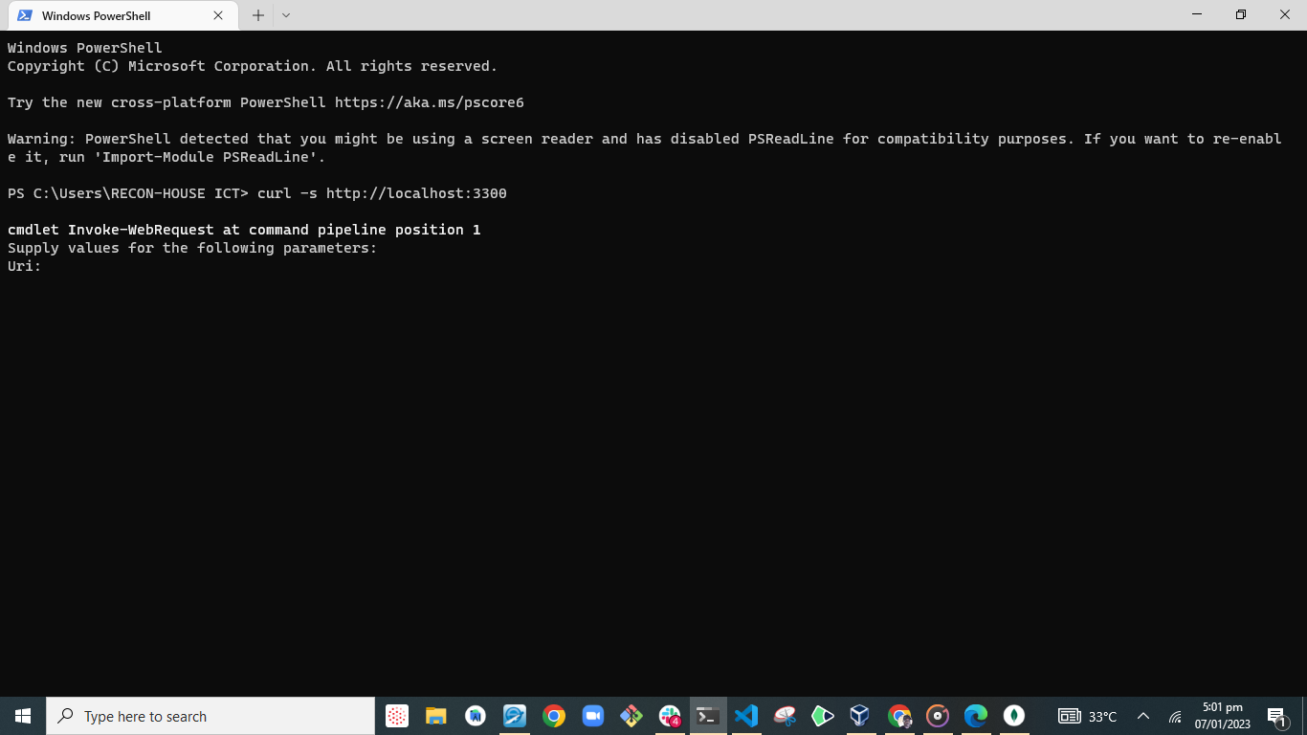

PUBLIC IP ADDRESS & PUBLIC DNS Name:

